Ballumbie Primary School

School Improvement Report
Session 2024 – 2025



Ballumbie Primary School
70 Lothian Cresent
Dundee. DD4 0HU
Tel 438617
Email: ballumbieprimary@dundeeschools.scot

This document shares and celebrates the improvements in our School and embraces all ages and stages. It is based upon our School Improvement Plan for session 2024 – 2025.

Ballumbie Primary School
70 Lothian Crescent,

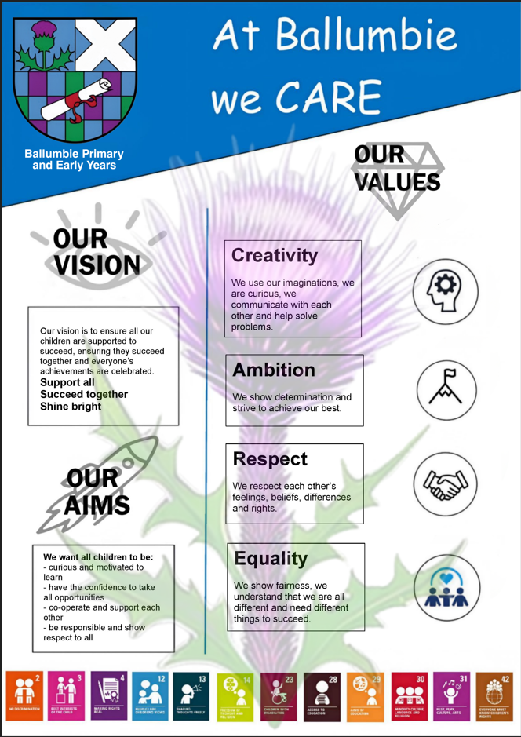

Context of the School:

Ballumbie Primary School is a non-denominational school and Early Years Centre situated in the Whitfield community in the North East area of Dundee. The school catchment area is varied with 61% of children living within the most deprived areas of our city (SIMD 1/2). 28% of all pupils have an additional support need.
The school currently has 390 pupils, 15 mainstream classes, 4 Supported classes and an Early Years setting for 3 – 5-year-olds with capacity for 60 children in the morning and afternoon and a two year old provision for 20 children again in both the morning and afternoon.
The school offers learners a wide range of experiences across the curriculum and through the wider life of the school. Ballumbie offers a wide range of wider achievement opportunities including Rock School for P7 pupils, opportunities to learn to play a range of musical instruments and perform in a school show. Our links with Active Schools and staff run clubs also ensure that all children have the opportunity to participate in physical activity, from Multi Sports to football, basketball, dance, netball and physical activities supporting children with additional needs.
The management structure of the school comprises of a Head Teacher, Depute Head Teacher, Principal Teacher P1 – P7, Principal Teacher Supporting Learners and an Early Years Manager.

Our Values are Important
Honesty Fairness Responsibility Support Cooperation Respect Inclusion

Attendance and Exclusion Data

Exclusion

2020/21 | 2021/22 | 2022/23 | 2023/24 | 2024/25 (at March 25)
4.4% | 22.3% | 7.3% | 4.9% | 3.3%

Attendance

2020/21 | 2021/22 | 2022/23 | 2023/24 | 2024/25
94.1% | 90.1% | 89.6% | 89.8% | 92.16%

Attainment Data 2024 - 2025
(percentages)
 | Reading | Writing | Talking and Listening | Numeracy
Primary 1  (CFE Early Level) | 72% | 75% | 80% | 80%
Primary 4  (CFE 1st Level) | 81% | 76% | 82% | 81%
Primary 7  (CFE 2nd Level) | 83% | 69% | 84% | 75%

Support – Succeed - Shine

Review of Improvement Progress for Session 2024 – 2025

IMPROVEMENT PRIORITY 1 – Raise attainment in literacy to 75% by June 2025

Progress and impact:

- All teaching staff were involved in the review and development of lesson standards for reading, writing, listening and talking and numeracy which has led to a consistency in teaching and focused professional dialogue as part of peer visits.
- Pedagogical professional reading groups have been established across all staff to develop knowledge of universal supports in inclusive practice.
- Collegiate discussions about class data with teaching colleagues from schools across Dundee supported targeted raising attainment strategies for each cohort and allowed time to share practice.
- Writing moderation activity has resulted in a clear consistency across staff in making judgements and agreeing next steps in learning.
Writing trackers are regularly referred to when assessing writing at all levels. Increased moderation activity with stage partners have shown that almost all staff’s professional judgements are consistent.
- Assessment overview for 25/26 has been collegiately agreed by all teaching staff. This will be embedded in year plan for session 25/26 to ensure consistency
- Primary 3 – Primary 4 teachers took part in writing project with Education Scotland. All classes made significant progress.

Next steps:

- All teachers to complete CYPIC Writing training with Education Scotland and Dundee Pedagogy team
- Develop a year plan of writing progression across P1- P7 for session 26/27
- Moderation – continue with model of moderation activity in line with benchmarks – focus on all area of literacy
- Attain Reading School award:
- Reading/Parent Council organise literacy events – reading café, reading displays, book reviews,

IMPROVEMENT PRIORITY 2 – Raise attendance levels for all children with attendance rates between 50% and 80%.

Progress and impact :
- School Improvement Partnership inquiry group created an action plan to support improved attendance activity that could be implemented across all SIP schools. Self Evaluation Attendance toolkit has been completed by individual schools and the Clarify Canvas planning tool has allowed us to identify and focus on children with attendance below 80% in June 2024.
- All children who were identified within the clarify canvas have an attendance intervention in place – Breakfast Club or Football club, both begin at 8.45am – 9.15am, this led to increased attendance levels of attendance for 70% of the group.
- Ongoing review of attendance data weekly by Depute Head and School and Family Worker HT and SFDW supported awareness raising of the importance of attendance and supports available to families.
- Parent voice survey was collated to share views of what draws children to school and barriers. Bullying Policy to be taken forward by H&WB Pupil group.
- Pull to School interventions were established – increased Leadership groups, Breakfast for all, Breakfast Sports Clubs and Fun Friday themed learning activities are now in place and organised by pupils and Sports Council, supporting a 3% increase in whole school attendance.

Next steps:

- Continue to promote attendance at school through fortnightly bulletins and ensure supports for families
- Children who have attendance below 80% will be part of targeted interventions with partnership agencies

IMPROVEMENT PRIORITY 3 – Increase leadership opportunities across our school to ensure children and staff voice impacts positive change

Progress and impact:

- All Primary 5 – Primary 7 teachers led change ideas, some linked to School Improvement Plan and a focus on Wider Achievements. This led to greater involvement in positive change and the staff team collegiately worked on a Leading Change plan to ensure all children and staff across Nursery to Primary are involved in the life of the school.
- Professional Reading groups were established with all support and teaching staff reading ‘The Inclusive Classroom’ to agree best practice and professional strategies to use with children to meet additional support needs. Some staff led the groups and professional discussions to agree change.
- Relationships policy has been reviewed by the staff team to review behaviour pathways and ensure consistency, and all staff were involved in the changes.
- Rights Respecting School group established by Principal Teacher and action plan was co-written with the pupil leadership group and Parent Council. The school Achieved Broze award and will embark on Silver Award.
- School values have been reviewed with families, staff and pupils. The values of Creativity, Ambition, Respect and Equality have been chosen with the overarching statement, At Ballumbie we CARE. Values trophies were introduced at our Sharing Success assemblies and The Health and Wellbeing group designed whole school posters to promote our vision, values and aims.

Next steps:

- Share our vision, values and aims with all stakeholders and ensure these permeate through all we do – assemblies to focus on vision, values and consistencies.
- Continue on our journey to achieve Rights Respecting School Silver award, Eco Bronze Award, Digital Schools Award and Reading School award led by school staff.
- Increase partnerships and ensure time for staff leading positive change

Pupil Equity Fund interventions

Increased staffing levels to support engagement in learning
- Teacher – enhanced staffing levels to support small group support work and children with additional support needs access the curriculum
- School and Family Worker to support school attendance and family engagement

Partnership Working
- Partnership with Rock School for all Primary 7 children
- Partnership with Best Foot Forward (Active Schools, NHS, Dundee FC Community Trust, Roundhouse, Heart Start and Fairfield Community Football) to
offer a variety of learning experiences for vulnerable groups to support attendance, enhance the curriculum experience and engage learners
- Partnership with Active Schools to employ a full time Active Schools Assistant to focus on attendance and engagement in learning, promote and develop social skills, resilience, health and wellbeing and sport in the community

Cost Of The School Day interventions

Supporting children and families
We work with a number of community partners to support the Cost of The School Day to ensure that all children can access their education and all school activities without barriers.
Current interventions and supports:
Access to food larder and clothing bank for families
Make use of Pupil Equity Fund to support school trips and P7 residential
School and Family Worker supports signposting for families
Ballumbie PS are part of the Cost of the School Day Voice Network
Partnerships include:
Dundee Bairns to ensure all children have access to daily breakfast
Clothing and uniform support from Cosy Bairns, One Parent Families and Togs for Tots
Support with cash donations and gifts from Cash for kids, Help for Kids, Community workplace donations

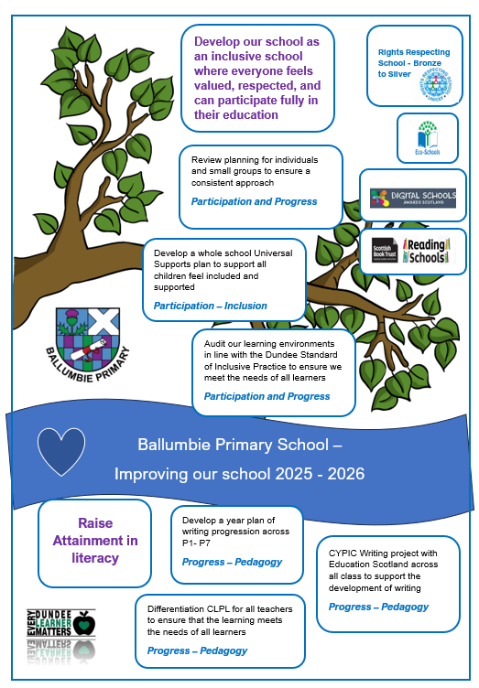

Improvement Priorities for Session 2025 – 2026

- Raise attainment in literacy to 80% by June 2026

- Develop our school as an inclusive school where everyone feels valued, respected, and can participate fully in their education

